

VERSA SYSTEM Manual

Johnny Tian



April 28, 2023

Ikonmotorsports

15305 Stafford St, City of Industry, CA 91744

Table of Contents

AIS SYSTEM 2

Setup 2

Export Data from AIS System 2

VERSA REPORT SYSTEM 4

Sale Report: 4

Inventory Report: 5

SQL Query 5

Bin Location 5

**Reference:** 6

**All example files could be found at *Y:\Project Related\Project Share\Versa Project\data*** 6

# AIS SYSTEM

## Setup

1. In the path: Y:\Project Related\Project Share\Versa Project\dist, copy AIS Report.exe to your local Drive
2. Create a “Data” Folder at your C Drive if you do not have. All data exported will be stored in this folder, if you do not have this folder, you will not be able to export any data from AIS System.

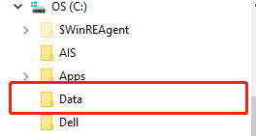

## Export Data from AIS System

1. Sales Report Data Preparation
2. Item.CSV: Open AIS System🡪Data Exchange🡪 AIS Data Export-🡪Products. Please first double-click the target file, then click Export after you see descriptions at “Export Description” on the right. Then click O.K (Ps: No need to be renamed) 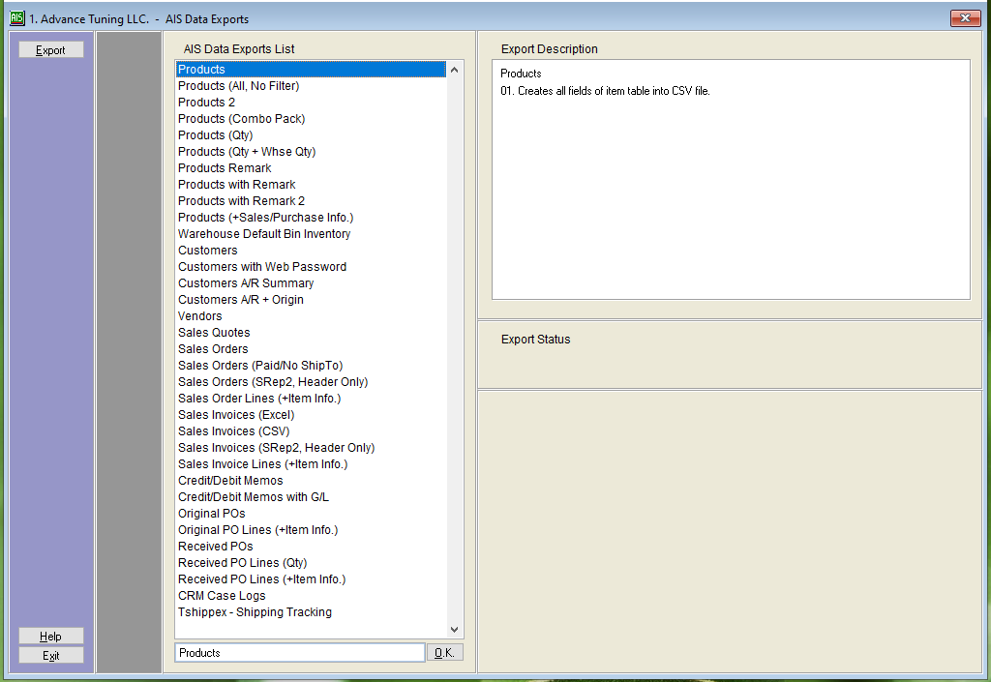
3. 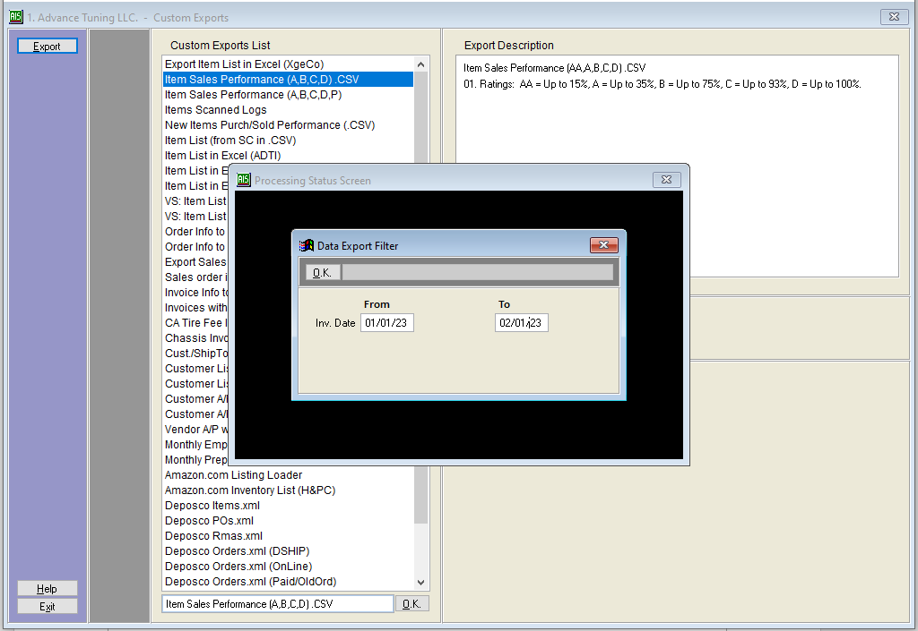Itemyyyy-mm.CSV: Data Exchange🡪Custom Exports🡪Item Sales Performance (A,

B,C,D).CSV🡪Export🡪Select Date🡪O.K(Ps: Need to be renamed)

1. Inventory Report Data Preparation
2. 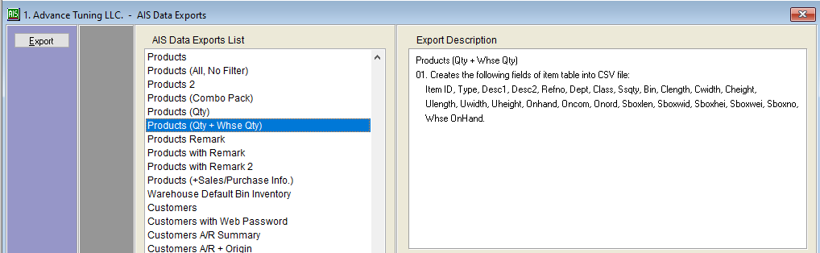Item_Qty_WhseQty.CSV: Data Exchange🡪AIS Data Export🡪 Products (Qty+Whse Qty) 🡪Export🡪O.K(Ps: No need to be renamed)
3. Item_Xx.CSV: Sales Assistant-->Items Sold by US States🡪 Sales Dates From/To🡪Select ALL: Include Origin 1, DSHIP, EBAY, AMZN, ALL OTHERS🡪Select States corresponded with CSV Files🡪Display🡪File (Ps:Need to be renamed)

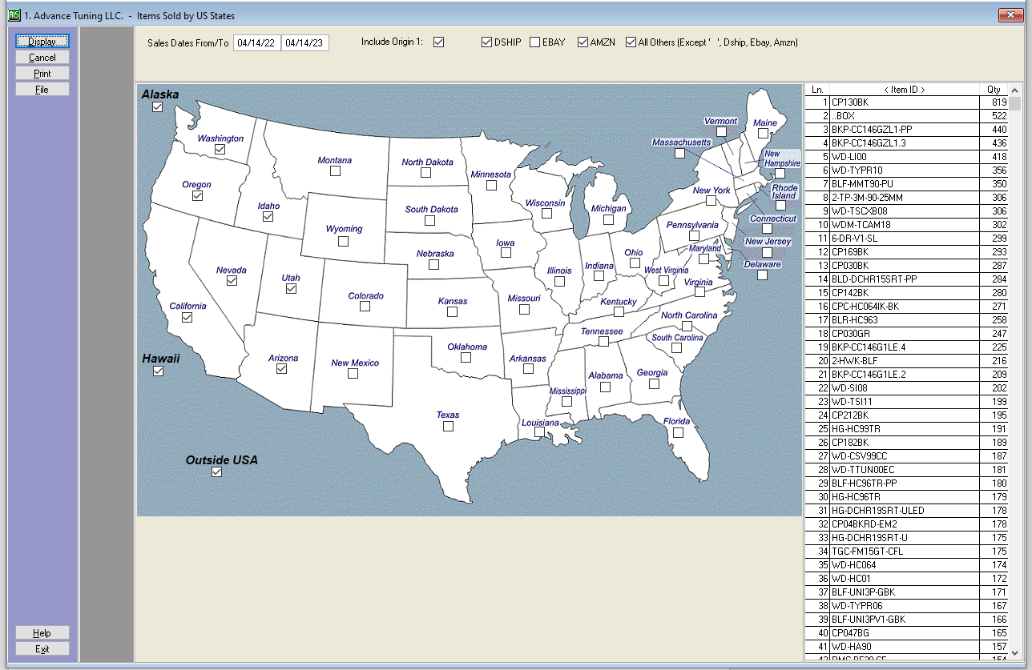

# VERSA REPORT SYSTEM

## Sale Report:

1. Click “Open CSV Files”, tap “ctrl” to select multiple CSV files then import them to the text content. Then click “Create”, the created file will be automated generated in “my_report” folder.
2. To generate a sale report file, you will need a main CSV file (Item.CSV) and multiple months sale files (Itemyyyy-mm.CSV).

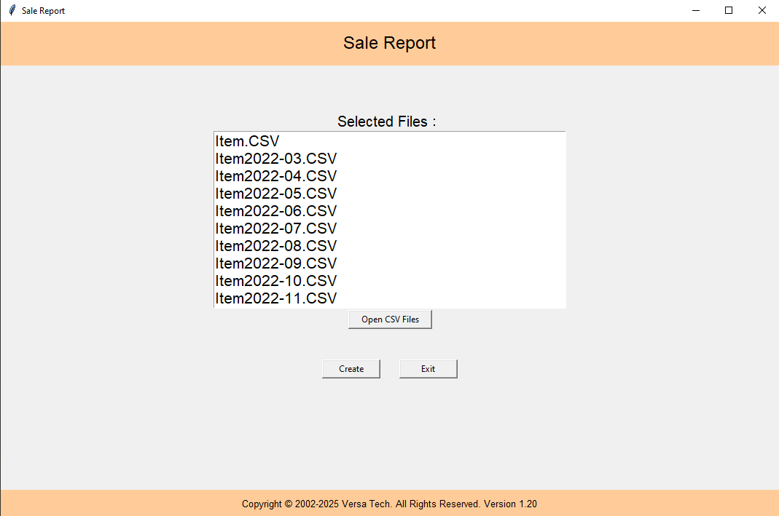

1. Itemyyyy-mm.CSV Format: yyyy-mm represents the specific month and year of each file. Example: Item2022-01.CSV, Item2022-03.CSV, etc., otherwise the file will not be recognized.

## Inventory Report:

1. Click “Open CSV Files”, tap “ctrl” to select multiple CSV files then import them to the text content. Then click “Create”, the created file will be automated generated in “my_report” folder.
2. To generate an Inventory report file, you will need a main CSV file (Item_Qty_WhseQty.CSV) and four location files(Item_Ww.CSV,Item_Wm.CSV, Item_En.CSV, Item_Es.CSV).

## SQL Query:

1. Select target data--> click Submit--> file will be exported to “my_report” directory

## Bin Location:

1. Input your keyword letters (less than 6 letters) for Bin Location 🡪 click OK 🡪 generated in “my_report” directory

**Reference:**

**All example files could be found at *Y:\Project Related\Project Share\Versa Project\data***